Adding ClinicalKey Images to PowerPoint
ClinicalKey has millions of images available to download to enhance your lectures. Using ClinicalKey’s Presentation Maker, you can quickly import ClinicalKey images (including citation information) into your own PowerPoint presentations.

Create a Personal Account
- Access ClinicalKey.
- In order to use the Presentation Maker feature, you need to create a free Personal Account. Select Register in the upper right corner. (Select Login if you already have an account.) Fill out the form to create your free username and password.

Search for an Image
After you are logged into your Personal Account, search ClinicalKey to locate an image you want to use. Tip: On the search results screen, you can select Images in the Filter By box to narrow your search results to just images.
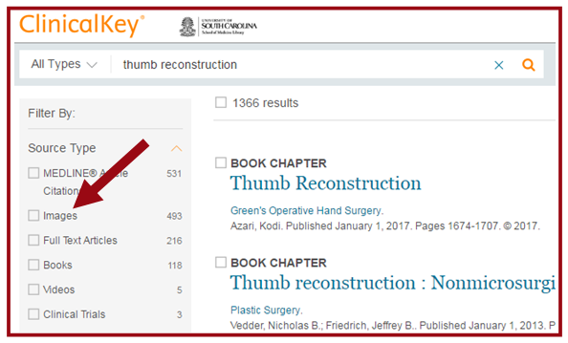

Save an Image to Presentation Maker
- Once you locate an image, select the Add to Presentation icon. (It is the second icon listed.)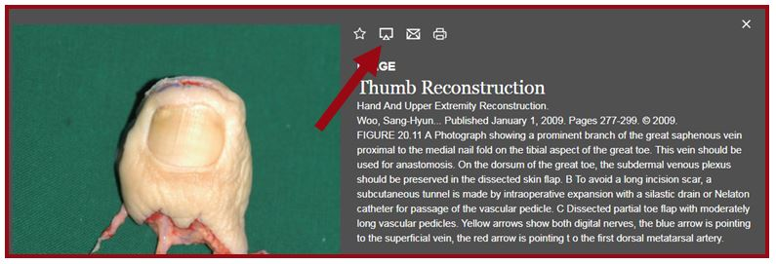
- The Add to Presentation pop-up window appears. Using the Select Presentation drop-down menu, select Create New.
- Enter a name for your presentation and click Save.
- Next, select Add and view presentation.
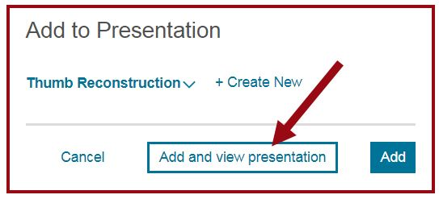

Export an Image
On the Presentation Maker page, select the Export link on the right side of the page.
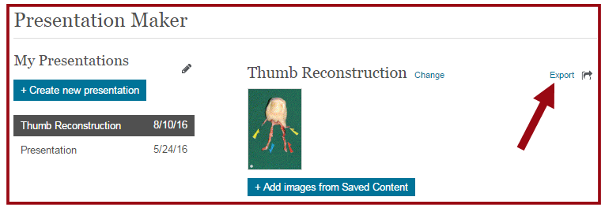
PowerPoint opens with a slide that includes your image and citation/copyright information. (Depending on which browser you use, PowerPoint may also be a minimized icon on the lower left corner of your screen.)
