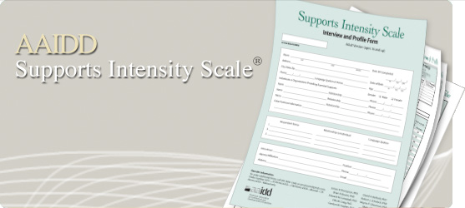
WHAT IS THE SUPPORTS INTENSITY SCALE?
The Supports Intensity Scale (SIS) is a national assessment used to determine the level of supports needed for an adult with a disability to be as successful as possible. The SIS encompasses all areas of a person’s life (home living, community living, employment, etc.). Please visit www.siswebsite.org to read more about the SIS.
WHAT SHOULD YOU CONSIDER WHEN SETTING UP A SIS INTERVIEW?
- The assessment generally takes about 2 hours but please plan ahead for 3 hours. If for any reason an individual may not be able to participate in the full interview, please make arrangements accordingly.
- In addition to the individual, we need at least 2 respondents and no more than 5 respondents that are willing to participate. Ideally, one respondent from Residential/Family and the other respondent from Day Support/Vocational. Again, 2 respondents are needed at all times. A respondent is someone that knows the individual being interviewed (caregiver, family member, spouse, case manager, job coach, etc.).
- Please consider the individual’s schedule, respondents’ schedule and other factors (meal times, shift changes, etc.) when choosing a time for the interview.
- The assessment is facilitated as a discussion among ALL respondents and the individual interviewed; full participation is expected. Please make sure that the individual’s guardian/family is notified before the interview takes place.
- Due to the nature of the assessment and sensitive topics, please make sure ONLY the individual interviewed and the chosen respondents are in the room. Please make sure the respondents are people that the individual being interviewed feels comfortable talking in front of.
WHAT SHOULD YOU ASK OF THE RESPONDENTS?
For further information or for questions about scheduling,
please contact:
Kristin Penninger
(803) 935-5625
Kristin.penninger@uscmed.sc.edu

- Be open and frank in discussions
- Full participation (ALL RESPONDENTS EQUALLY!!!)
- Know the individual being interviewed (at least 3 months)
- Please no food, cell phones, videotaping, audiotaping, laptops or other distracting devices

