PROCESS FOR OBTAINING PMCID NUMBERS FOR CITATIONS
- Go to Pub Med Central’s List of journals @ http://www.ncbi.nlm.nih.gov/pmc/journals/?filter=t2&titles=current&search=journals
- Enter the name of your journal in the Search box.
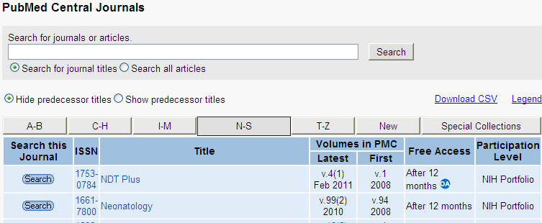
- You can also select from the alphabetical tabs and look for the journal by scrolling down the alphabetical list.
- 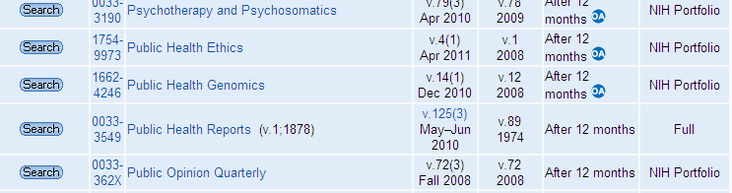
- If the journal is on the Pub Med Central list, you can then click on it to find the appropriate year, volume, and issue. If the journal is NOT on the Pub Med Central list, there will be no PMCID.
- 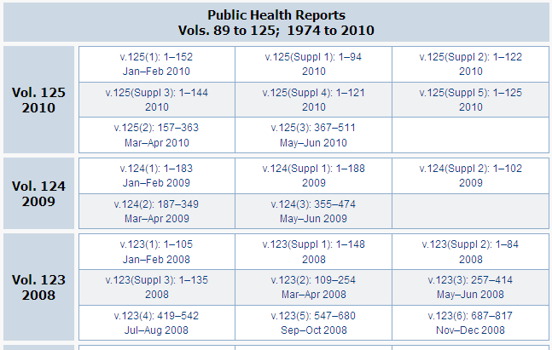

- When you find the article, the PMCID will be with the abstract.

